**LAB FILE REPORT**

Final Record

for

CSE3016-Computer Graphics and Multimedia

**

*Submitted by*

**<Aryaman Mishra-19BCE1027>**

*To*

**DR. S. LINGASWAMY**

**BACHELOR OF TECHNOLOGY**

*in*

**COMPUTER SCIENCE AND ENGINEERING**



May 2021

**Table of contents**

**Content Page no.**

* Lab 1:Multiple Shapes in C…………………………………………3
* Lab 2:Scenery,Flag and Object(Rocket)…………………………...16
* Lab 3:Animation/Moving in TurboC………………………………26
* Lab 4:Line Drawing Algorithms…………………………………...31
* Lab 5:Circle Drawing and Clipping………………………………..37
* Lab 6:2D Transformation …………………………………………..52
* Lab 7:3D Transformation …………………………………………..66
* Lab 8:Audio Editing………………………………………………..95
* Lab 9:Video Editing………………………………………………105
* Lab 10:Animation Making………………………………………..111

**LAB 1**

**Multiple Shapes in C(with proof of Code in Turbo C++)**

Single Line:

#include<graphics.h>

#include<stdio.h>

#include<conio.h>

void main(void){

int gdriver=DETECT,gmode;

int x1=200,y1=200;

int x2=300,y2=300;

clrscr();

initgraph(&gdriver,&gmode,"c:\\turboc3\\bgi");

line(x1,y1,x2,y2);

getch();

closegraph();

}

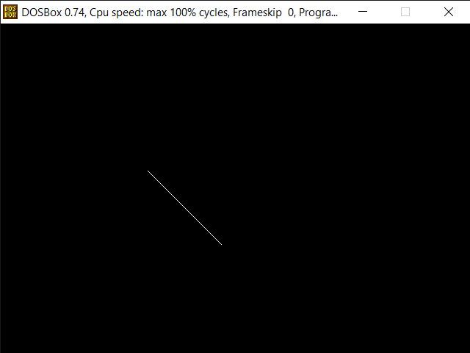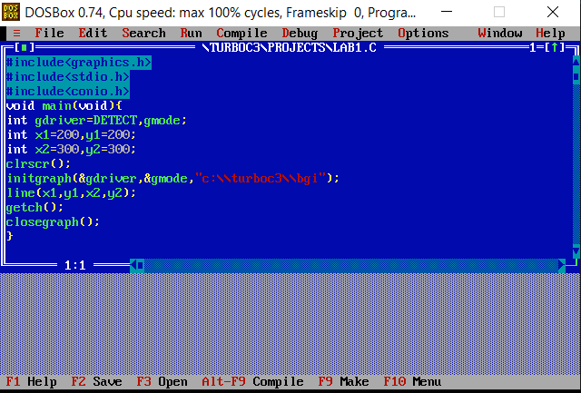

Multiple Lines:

#include<stdio.h>

#include<graphics.h>

#include<conio.h>

int main()

{

int gd=DETECT,gm;

initgraph(&gd,&gm,"c:\\turboc3\\bgi");

line(150,150,450,150);

line(150,200,450,200);

line(150,250,450,250);

getch();

closegraph();

return 0;

}

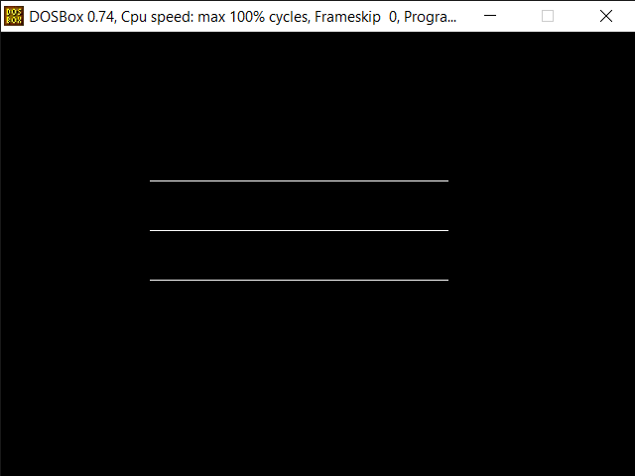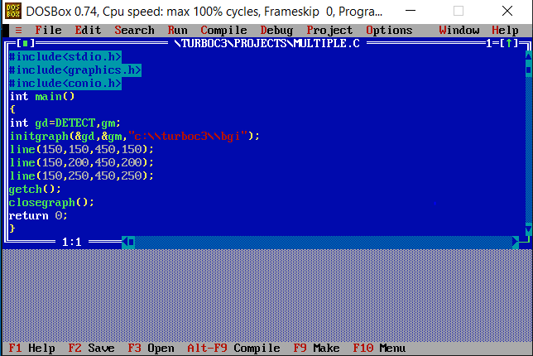

Rectangle:

#include<stdio.h>

#include<graphics.h>

#include<conio.h>

int main()

{

int gd = DETECT, gm;

int left = 150, top = 150;

int right = 450, bottom = 450;

initgraph(&gd, &gm, "c:\\turboc3\\bgi");

rectangle(left, top, right, bottom);

getch();

closegraph();

return 0;

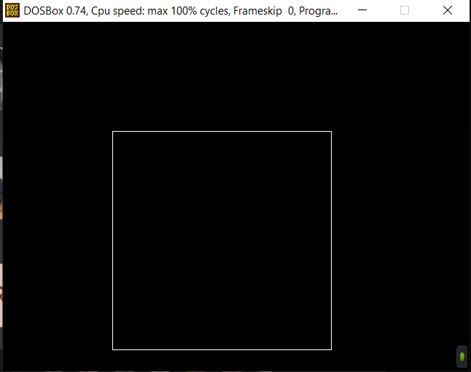}

Circle:

#include<stdio.h>

#include<graphics.h>

#include<conio.h>

int main()

{

int gd = DETECT, gm;

initgraph(&gd, &gm, "c:\\turboc3\\bgi");

circle(250, 200, 50);

getch();

closegraph();

return 0;}

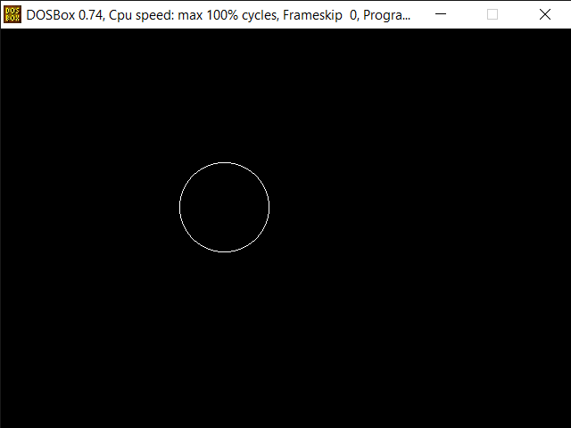

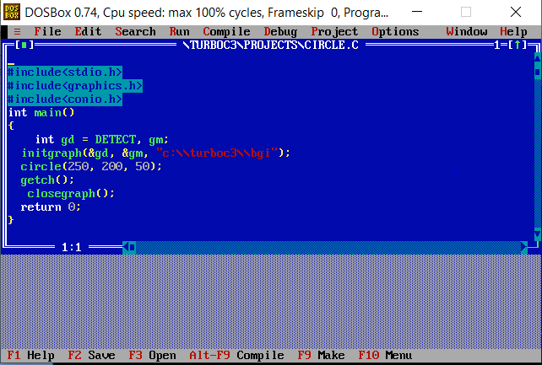

Arc:

#include<stdio.h>

#include<graphics.h>

#include<conio.h>

int main(){

int gd = DETECT, gm;

int x = 250;

int y = 250;

int start_angle = 155;

int end_angle = 300;

int radius = 100;

initgraph(&gd, &gm, "c:\\turboc3\\bgi");

arc(x, y, start_angle, end_angle, radius);

getch();

closegraph();

return 0;

}

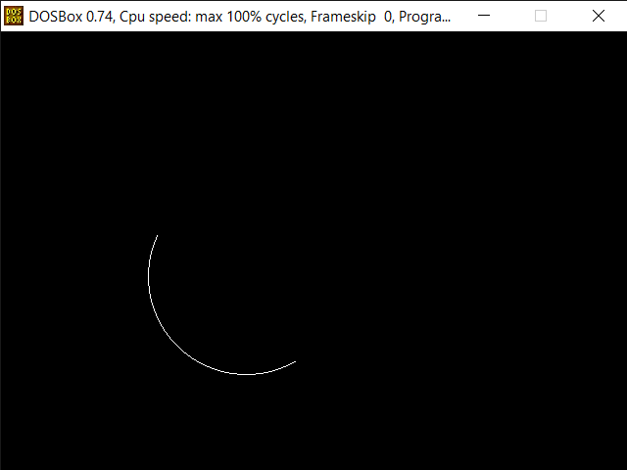

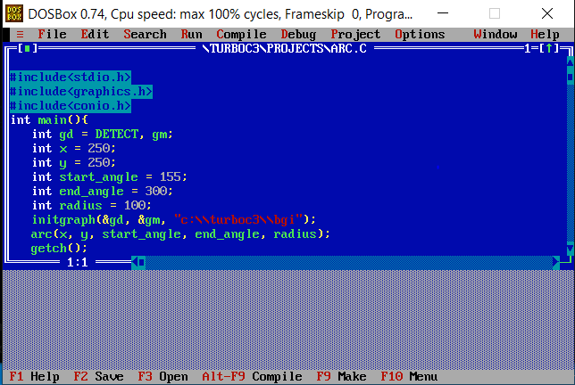

Hut:

#include<stdio.h>

#include<conio.h>

#include<graphics.h>

void main()

{

int gd=DETECT,gm;

clrscr();

initgraph(&gd,&gm,"c:\\turboc3\\bgi");

setcolor(3);

line(100,200,300,200);

line(100,400,300,400);

line(100,400,100,200);

line(300,400,300,200);

line(300,200,500,200);

line(300,400,500,400);

line(500,200,500,400);

line(170,250,270,250);

line(170,200,270,200);

line(170,250,170,400);

line(270,250,270,400);

line(200,50,400,50);

line(400,50,500,200);

line(300,200,200,50);

line(100,200,200,50);

getch();

closegraph();

}

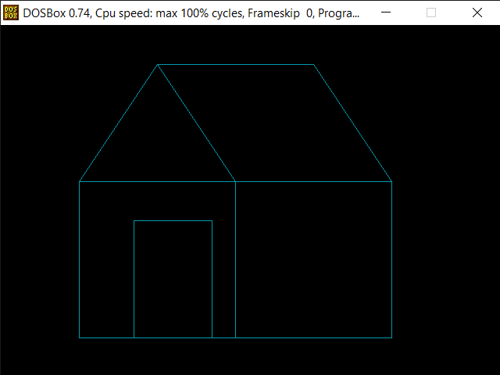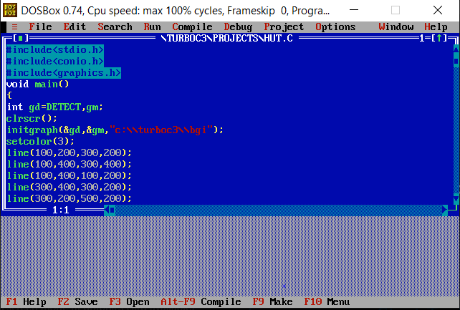

Fill Color:

#include<stdio.h>

#include<conio.h>

#include<graphics.h>

int main()

{

int gdriver = DETECT,gmode;

initgraph(&gdriver,&gmode,"c:\\turboc3\\bgi");

setfillstyle(SOLID_FILL,RED);

circle(200,200,50);

floodfill(202,202,15);

getch();

return 0;

}

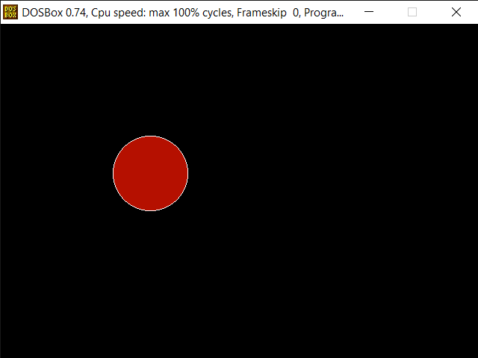

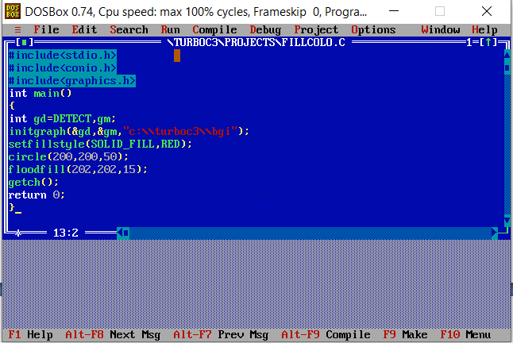

**Lab 2:Scenery,Flag and Object(Rocket)**

1.SCENERY

#include<stdio.h>

#include<conio.h>

#include<graphics.h>

#include<math.h>

#include<dos.h>

void main()

{

int gdriver=DETECT,gmode;

initgraph(&gdriver,&gmode,"C:\\TURBOC3\\BGI");

line(150,50,200,100);

line(150,50,80,120);

line(80,120,100,120);

line(150,50,350,50);

line(350,50,400,100);

line(100,100,100,200);

line(100,200,200,200);

line(200,100,200,200);

line(400,200,400,100);

line(200,200,400,200);

line(200,100,400,100);

rectangle(130,130,170,170);

rectangle(250,130,320,200);

line(320,130,305,140);

line(305,140,305,140);

line(250,130,265,140);

line(265,140,265,200);

line(100,200,90,210);

line(90,210,200,200);

line(190,210,200,200);

line(190,210,410,210);

line(400,200,410,200);

//HOUSE COLOR

setfillstyle(8,2);

floodfill(131,131,WHITE);

setfillstyle(11,7);

floodfill(101,101,WHITE);

setfillstyle(1,12);

floodfill(163,55,WHITE);

setfillstyle(1,12);

floodfill(82,119,WHITE);

setfillstyle(3,10);

floodfill(251,121,WHITE);

setfillstyle(1,6);

floodfill(150,205,WHITE);

setfillstyle(1,6);

floodfill(250,205,WHITE);

setfillstyle(5,12);

floodfill(310,145,WHITE);

setfillstyle(5,12);

floodfill(260,145,WHITE);

//tree

line(505,130,505,200);

line(532,130,532,200);

line(505,200,531,200);

line(480,130,560,130);

line(480,130,500,100);

line(500,100,480,100);

line(480,100,500,70);

line(500,70,480,70);

line(480,70,520,40);

line(560,130,540,100);

line(540,100,560,100);

line(560,100,540,70);

line(540,70,560,70);

line(560,70,520,40);

//color tree

setfillstyle(1,6);

floodfill(506,131,WHITE);

setfillstyle(1,2);

floodfill(510,101,WHITE);

//ROAD

line(270,210,290,390);

line(315,210,360,390);

line(0,390,290,390);

line(360,390,639,410);

line(0,410,639,410);

line(0,390,0,410);

line(639,390,639,410);

setfillstyle(1,6);

floodfill(1,391,WHITE);

//MOUNTAIN

line(100,180,0,180);

line(400,180,505,180);

line(532,180,639,180);

line(100,150,50,110);

line(50,110,0,150);

line(400,150,450,110);

line(450,110,505,150);

line(532,150,590,110);

line(590,110,639,150);

setfillstyle(1,8);

floodfill(50,50,WHITE);

setfillstyle(1,8);

floodfill(401,150,WHITE);

setfillstyle(1,8);

floodfill(535,150,WHITE);

setfillstyle(1,9);

//SKY

floodfill(0,0,WHITE);

setfillstyle(1,9);

floodfill(504,148,WHITE);

setfillstyle(1,9);

floodfill(535,132,WHITE);

//SUN

circle(70,50,40);

setfillstyle(1,14);

floodfill(71,51,WHITE);

//POND

ellipse(550,300,0,360,80,50);

setfillstyle(1,3);

floodfill(550,330,WHITE);

//GRASS COLOR

setfillstyle(1,2);

floodfill(20,50,WHITE);

setfillstyle(1,2);

floodfill(350,230,WHITE);

getch();

}

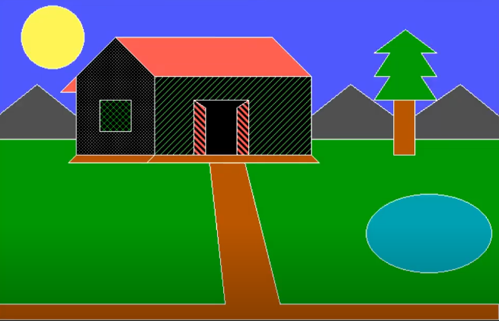

2.FLAG

#include<stdio.h>

#include<graphics.h>

#include<math.h>

#include<conio.h>

int main()

{

int gd,gm;

int r,i,a,b,x,y;

float PI=3.14;

detectgraph(&gd,&gm);

initgraph(&gd,&gm,"C:\\TURBOC3\\BGI");

setcolor(RED);

rectangle(100,100,450,150);

setfillstyle(SOLID_FILL,RED);

floodfill(101,101,RED);

setcolor(WHITE);

rectangle(100,150,450,200);

setfillstyle(SOLID_FILL,WHITE);

floodfill(101,151,WHITE);

setcolor(GREEN);

rectangle(100,200,450,250);

setfillstyle(SOLID_FILL,GREEN);

floodfill(101,201,GREEN);

a=275;

b=175;

r=25;

setcolor(BLUE);

circle(a,b,r);

//spokes

for(i=0;i<=360;i=i+15)

{

x=r*cos(i*PI/180);

y=r*sin(i*PI/180);

line(a,b,a+x,b-y);

}

getch();

closegraph();

return 0;

}



3.OBJECT(ROCKET)

#include<stdio.h>

#include<conio.h>

#include<graphics.h>

#include<maths.h>

#include<dos.h>

void main()

{

int gd=DETECT,gm=0;

initgraph(&gd,&gm,"C:\\TURBOC3\\BGI");

line(250,250,250,400);

line(320,250,320,400);

ellipse(285,260,0,360,35,10);

ellipse(285,400,0,360,35,10);

setfillstyle(SOLID_FILL,12);

fillellipse(285,260,35,10);

fillellipse(285,400,35,10);

setcolor(6);

setcolor(WHITE);

line(250,250,250,200);

line(320,250,320,200);

line(250,200,285,150);

line(320,200,285,150);

line(250,200,320,200);

line(260,200,285,165);

line(310,200,285,165);

line(270,200,285,175);

line(300,200,285,175);

line(280,200,285,185);

line(290,200,285,185);

line(260,200,260,252);

line(270,200,270,251);

line(280,200,280,250);

line(290,200,290,250);

line(300,200,300,251);

line(310,200,310,252);

line(250,400,220,450);

line(320,400,350,450);

line(220,450,350,450);

setfillstyle(SOLID_FILL,4);

getch();

closegraph();

}

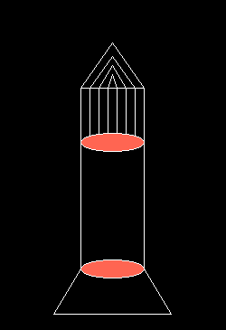

**Lab 3:Animation/Moving in TurboC**

#include<stdio.h>

#include<conio.h>

#include<graphics.h>

#include<math.h>

#include<dos.h>

void main()

{

int gd=DETECT,gm=0,i;

initgraph(&gd,&gm,"C:\\TURBOC3\\BGI");

for(i=0;i<300;i++)

{

cleardevice();

line(250,250-i,250,400-i);

line(320,250-i,320,400-i);

ellipse(285,260-i,0,360,35,10);

ellipse(285,400-i,0,360,35,10);

setfillstyle(SOLID_FILL,12);

fillellipse(285,260-i,35,10);

fillellipse(285,400-i,35,10);

setcolor(6);

setcolor(WHITE);

line(250,250-i,250,200-i);

line(320,250-i,320,200-i);

line(250,200-i,285,150-i);

line(320,200-i,285,150-i);

line(250,200-i,320,200-i);

line(260,200-i,285,165-i);

line(310,200-i,285,165-i);

line(270,200-i,285,175-i);

line(300,200-i,285,175-i);

line(280,200-i,285,185-i);

line(290,200-i,285,185-i);

line(260,200-i,260,252-i);

line(270,200-i,270,251-i);

line(280,200-i,280,250-i);

line(290,200-i,290,250-i);

line(300,200-i,300,251-i);

line(310,200-i,310,252-i);

line(250,400-i,220,450-i);

line(320,400-i,350,450-i);

line(220,450-i,350,450-i);

delay(200);

}

getch();

closegraph();

}

Starting

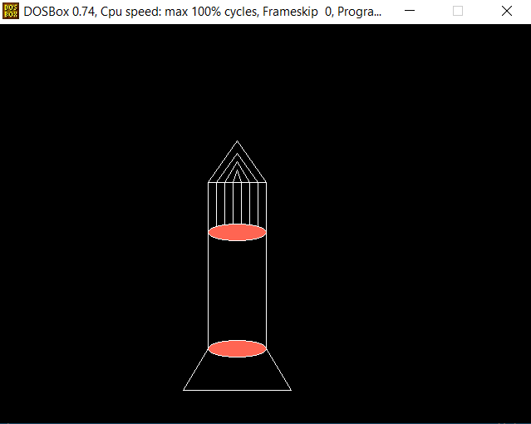

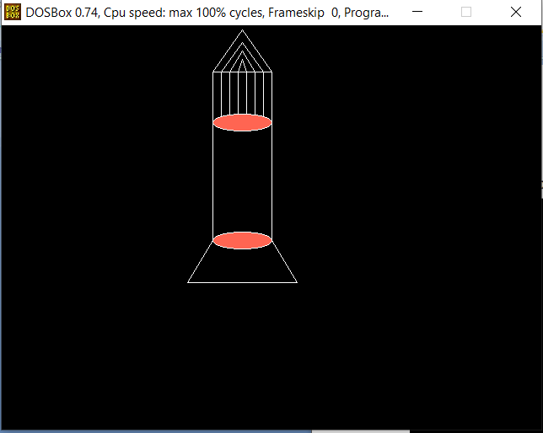

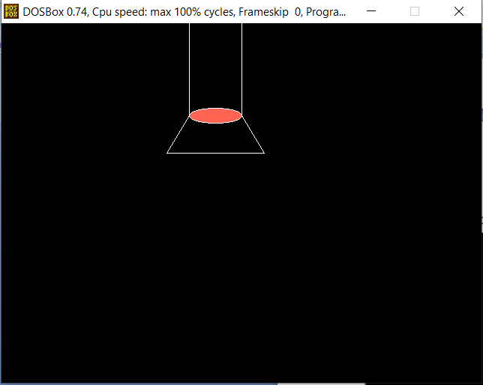

**Lab 4:Line Drawing Algorithms**

**Program for DDA Line Drawing Algorithm in C**

#include<stdio.h>

#include<stdlib.h>

#include<graphics.h>

#include<math.h>

void LineDDA(int x0,int y0,int x1, int y1)

{

double xIncrement,yIncrement,x,y;

int dx = x1 - x0,dy = y1-y0,steps,i;

if(abs(dx)>abs(dy)) steps = abs(dx);

else steps = abs(dy);

//one of these will be 1 or -1

xIncrement = (double)dx/(double)steps;

yIncrement = (double)dy/(double)steps;

x = x0;

y = y0;

putpixel((int)x,(int)y,WHITE);

for(i = 0;i < steps; i++)

{

x+=xIncrement;

y+=yIncrement;

putpixel((int)x,(int)y,WHITE);

}

}

void main()

{

int gd = DETECT,gm;

int x0 = 100,y0 = 100;

int x1 = 400,y1 = 400;

initgraph(&gd,&gm,"c:\\turboc3\\bgi");

clrscr();

LineDDA(x0,y0,x1,y1);

getch();

closegraph();

}

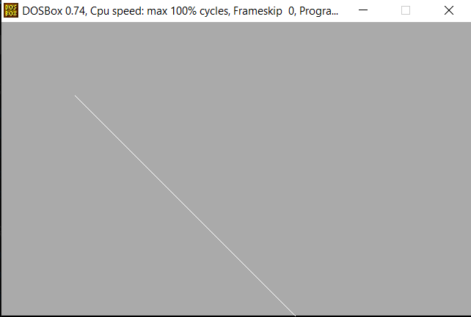

## Program for Bresenham's Line Algorithm

## Algorithm in C

## #include<stdio.h>

## #include<stdlib.h>

## #include<graphics.h>

## #include<math.h>

## #include<conio.h>

## void LineBres(int x0,int y0,int x1,int y1)

## {

## int dx=abs(x1-x0),dy=abs(y1-y0);

## int d=2*dy-dx,twoDy=2*dy,twoDyMinusDx=2*(dy-dx);

## int x,y;

## if(x0>x1)

## {

## x=x1;

## y=y1;

## x1=x0;

## }

## else

## {

## x=x0;

## y=y0;

## }

## putpixel((int)x,(int)y,RED);

## while(x<x1)

## {

## x++;

## if(d<0)d+=twoDy;

## else

## {

## y++;

## d+=twoDyMinusDx;

## }

## putpixel((int)x,(int)y,RED);

## }

## }

## void main()

## {

## int gd = DETECT,gm;

## int x0 = 220,y0 = 220;

## int x1 = 380,y1 = 380;

## initgraph(&gd,&gm,"C:\\TURBOC3\\BGI");

## clrscr();

## LineBres(x0,y0,x1,y1);

## getch();

## closegraph();

## }

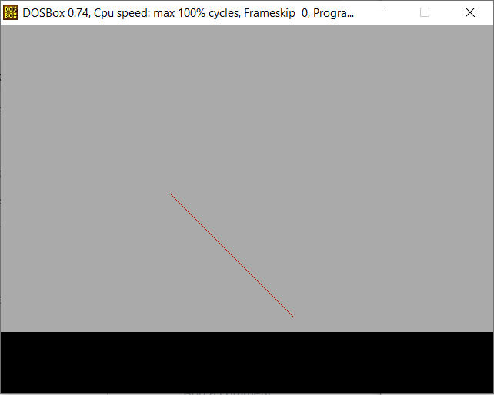

**Lab 5:Circle Drawing and Clipping**

1. Midpoint circle drawing
2. Liang- Barsky Line clipping
3. Weiler Atherton Polygon clipping

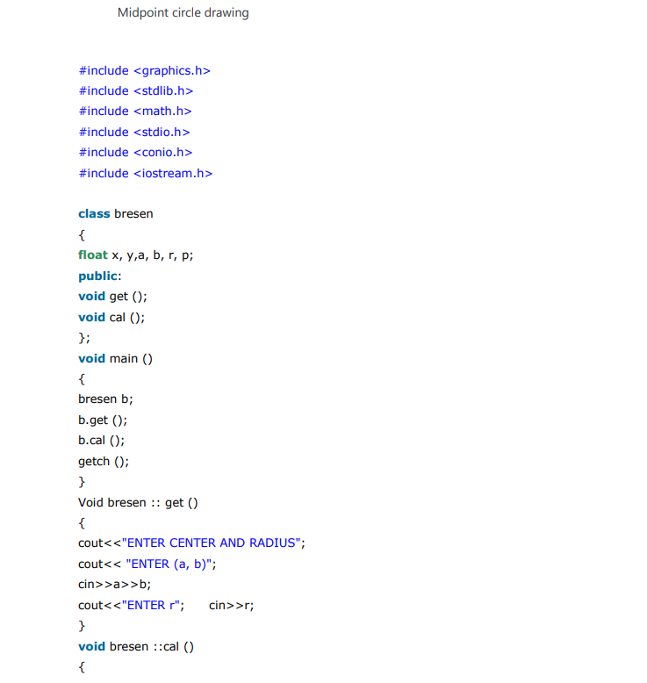

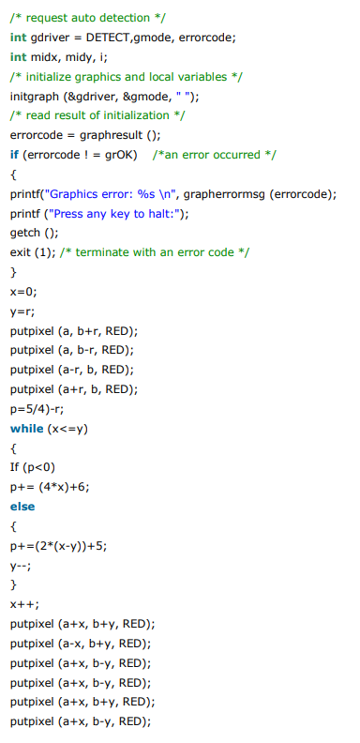

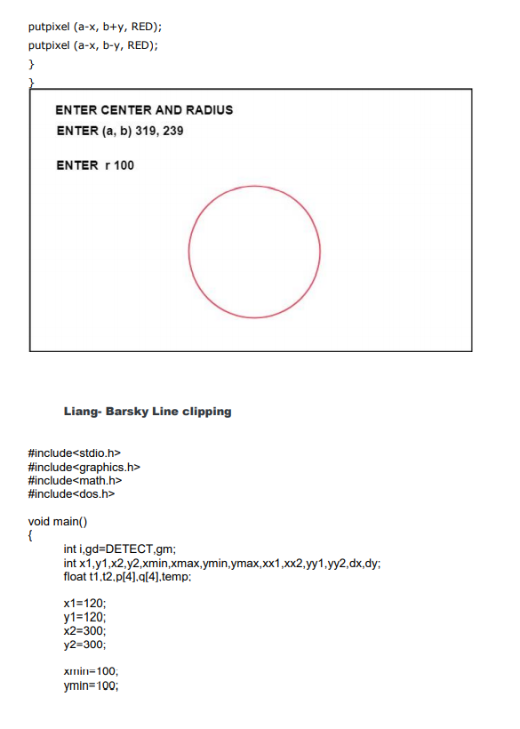 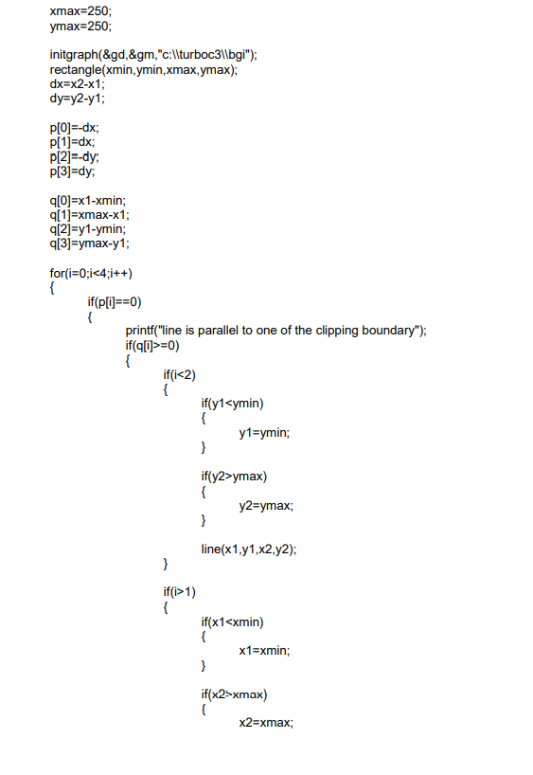 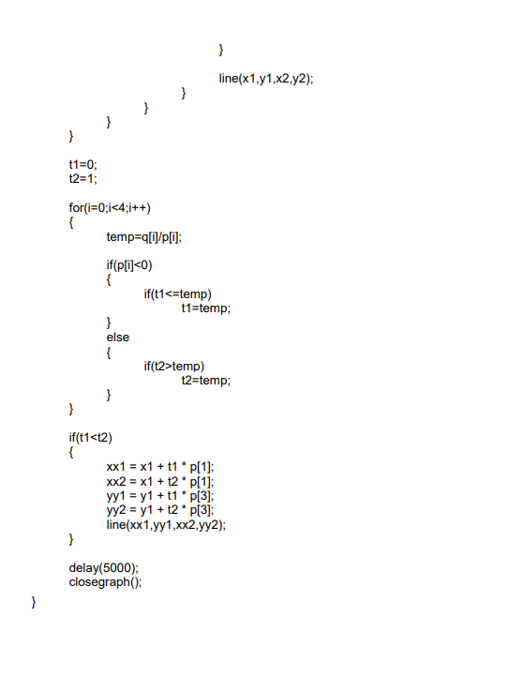 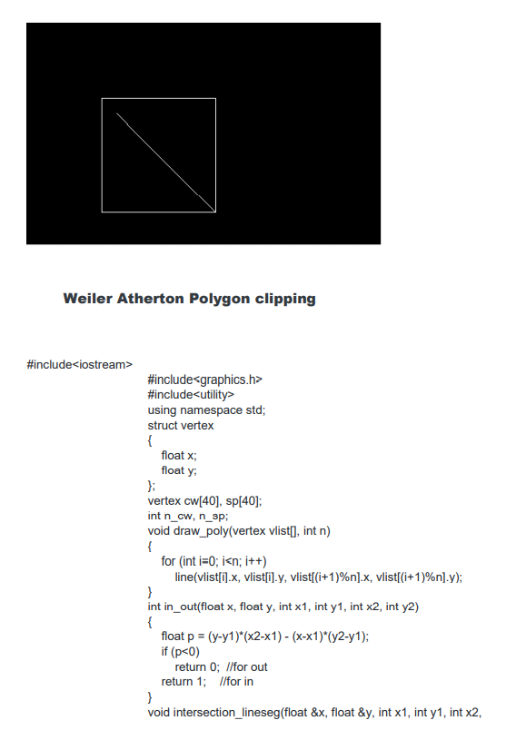 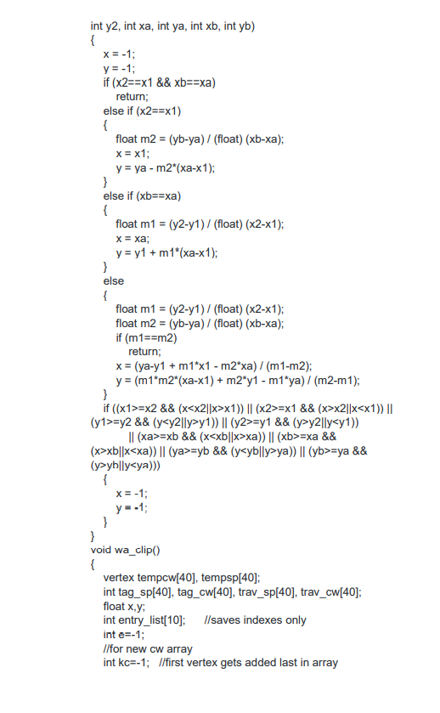 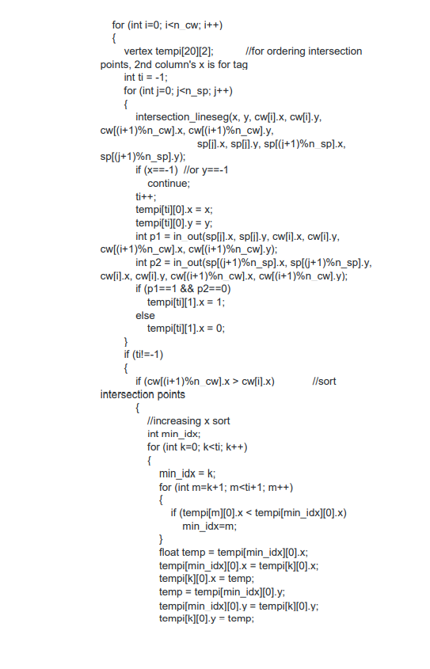 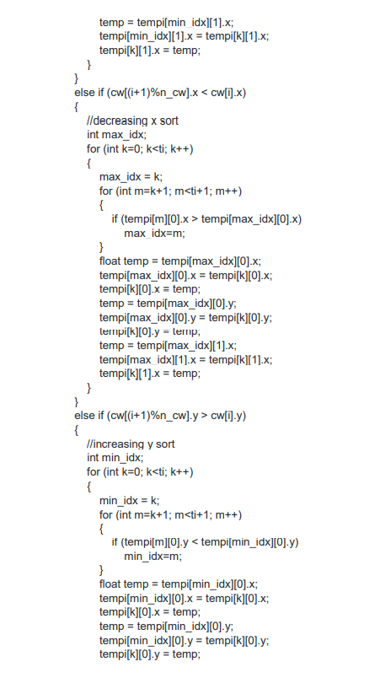 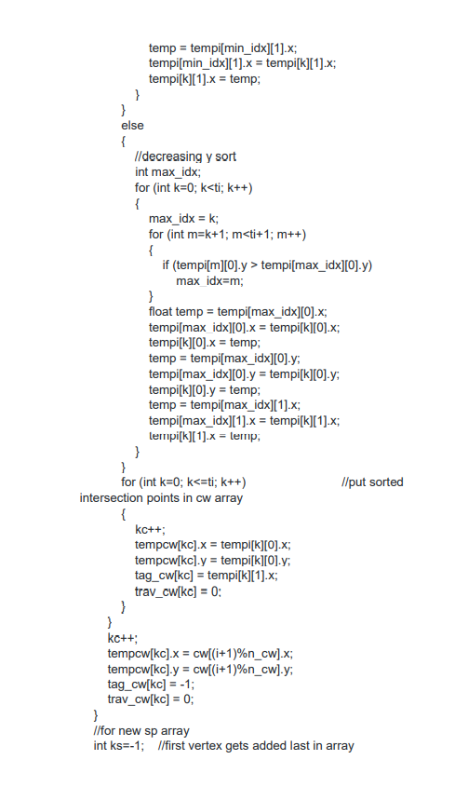 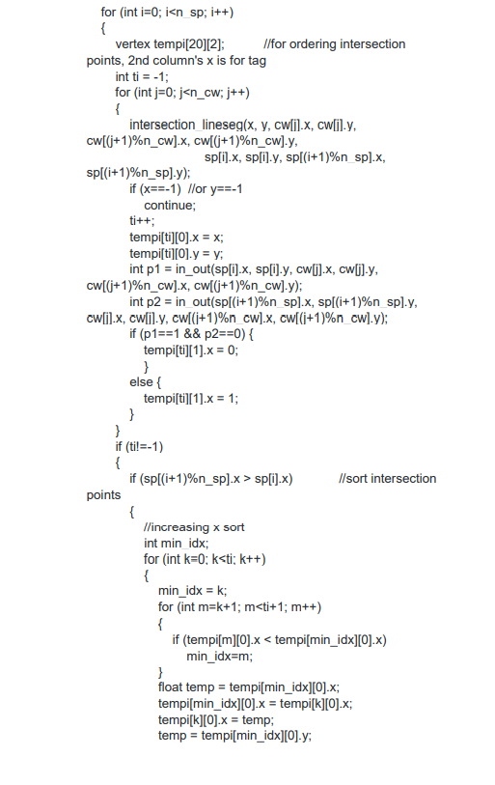 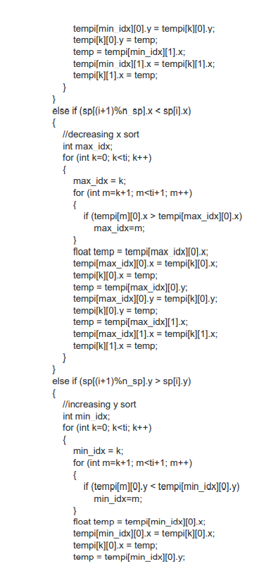 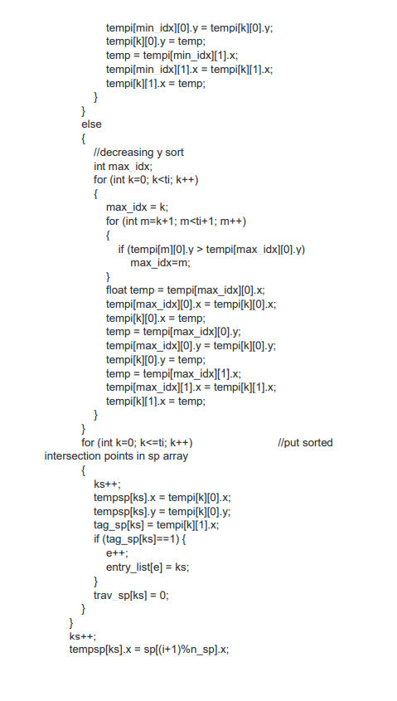 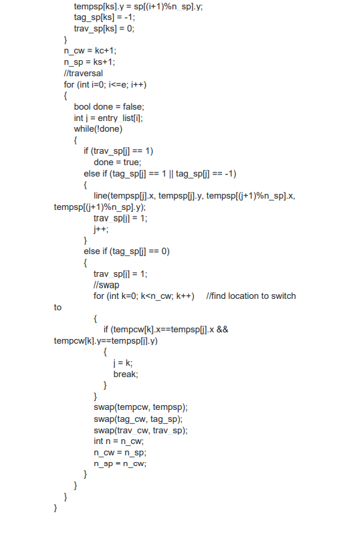 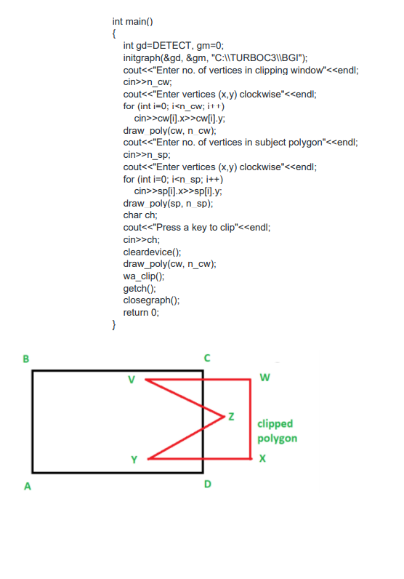

**Lab 6:2D Transformation**

#include <stdio.h>

#include<graphics.h>

#include<stdlib.h>

#include<conio.h>

#include<math.h>

void DrawFn();

void translate();

int graDriver=DETECT,graMode;

int n,xs[100],ys[100],i,xshift,yshift;

void DrawFn()

{

for(i=0;i<n;i++)

{

line(xs[i],ys[i],xs[(i+1)%n],ys[(i+1)%n]);

}

}

void translate()

{

for(i=0;i<n;i++)

{

xs[i]+=xshift;

ys[i]+=yshift;

}

}

void refx(int x1,int x2,int x3,int y1,int y2,int y3){

line(320,0,320,430);

line(0,240,640,240);

x1=(320-x1)+320;

x2=(320-x2)+320;

x3=(320-x3)+320;

line(x1,y1,x2,y2);

line(x2,y2,x3,y3);

line(x3,y3,x1,y1);

}

void refy(int x1,int x2,int x3,int y1,int y2,int y3){

line(320,0,320,430);

line(0,240,640,240);

y1=(240-y1)+240;

y2=(240-y2)+240;

y3=(240-y3)+240;

line(x1,y1,x2,y2);

line(x2,y2,x3,y3);

line(x3,y3,x1,y1);

}

void findNewCoordinate(int s[][2], int p[][1])

{

int temp[2][1] = { 0 };

for (int i = 0; i < 2; i++)

for (int j = 0; j < 1; j++)

for (int k = 0; k < 2; k++)

temp[i][j] += (s[i][k] * p[k][j]);

p[0][0] = temp[0][0];

p[1][0] = temp[1][0];

}

void scale(int x[], int y[], int sx, int sy)

{

// Triangle before Scaling

line(x[0], y[0], x[1], y[1]);

line(x[1], y[1], x[2], y[2]);

line(x[2], y[2], x[0], y[0]);

// Initializing the Scaling Matrix.

int s[2][2] = { sx, 0, 0, sy };

int p[2][1];

// Scaling the triangle

for (int i = 0; i < 3; i++)

{

p[0][0] = x[i];

p[1][0] = y[i];

findNewCoordinate(s, p);

x[i] = p[0][0];

y[i] = p[1][0];

}

// Triangle after Scaling

line(x[0], y[0], x[1], y[1]);

line(x[1], y[1], x[2], y[2]);

line(x[2], y[2], x[0], y[0]);

}

int main () {

char choice;

printf("Enter 1 for translation,2 for reflection,3 for rotation,4 for scaling,5 for shearing along x axis,6 for shearing along y axis.\n");

scanf("%c", &choice)

switch(choice) {

case '1' :

int graDriver=DETECT,graMode;

int n,xs[100],ys[100],i,xshift,yshift;

printf("Enter number of sides of polygon: ");

scanf("%d",&n);

printf("Enter co-rdinates: x,y for each vertex ");

for(i=0;i<n;i++)

scanf("%d%d",&xs[i],&ys[i]);

printf("Enter distances for translation (in x and y directions): ");

scanf("%d%d",&xshift,&yshift);

initgraph(&graDriver,&graMode,"C:\\TURBOC3\\BGI\\");

cleardevice();

//drawing original polygon in RED color

setcolor(RED);

DrawFn();

//Doing translation

translate();

//drawing translated polygon in BLUE color

setcolor(BLUE);

DrawFn();

getch();

break;

case '2' :

int gd=DETECT,gm;

int x1,y1,x2,y2,x3,y3;

clrscr();

initgraph(&gd,&gm,"c://turboc3//bgi");

line(320,0,320,430);

line(0,240,640,240);

x1=150;y1=100;

x2=220;y2=220;

x3=220;y3=110;

line(x1,y1,x2,y2);

line(x2,y2,x3,y3);

line(x3,y3,x1,y1);

getch();

refx(x1,x2,x3,y1,y2,y3);

getch();

refy(x1,x2,x3,y1,y2,y3);

getch();

closegraph();

break;

case '3' :

intgd=0,gm,x1,y1,x2,y2,x3,y3;

double s,c, angle;

initgraph(&gd, &gm, "C:\\TURBOC3\\BGI");

setcolor(RED);

printf("Enter coordinates of triangle: ");

scanf("%d%d%d%d%d%d",&x1,&y1,&x2,&y2, &x3, &y3);

setbkcolor(WHITE);

cleardevice();

line(x1,y1,x2,y2);

line(x2,y2, x3,y3);

line(x3, y3, x1, y1);

getch();

setbkcolor(BLACK);

printf("Enter rotation angle: ");

scanf("%lf", &angle);

setbkcolor(WHITE);

c = cos(angle *M_PI/180);

s = sin(angle *M_PI/180);

x1 = floor(x1 * c + y1 * s);

y1 = floor(-x1 * s + y1 * c);

x2 = floor(x2 * c + y2 * s);

y2 = floor(-x2 * s + y2 * c);

x3 = floor(x3 * c + y3 * s);

y3 = floor(-x3 * s + y3 * c);

cleardevice();

line(x1, y1 ,x2, y2);

line(x2,y2, x3,y3);

line(x3, y3, x1, y1);

getch();

closegraph();

case '4' :

int x[] = { 100, 200, 300 };

int y[] = { 200, 100, 200 };

int sx = 2, sy = 2;

int gd, gm;

detectgraph(&gd, &gm);

initgraph(&gd, &gm," ");

scale(x, y, sx,sy);

getch();

break;

case '5' :int gd=DETECT,gm;

int x,y,x1,y1,x2,y2,x3,y3,shear_f;

initgraph(&gd,&gm,"C:\\TURBOC3\\BGI");

printf("\n please enter first coordinate = ");

scanf("%d %d",&x,&y);

printf("\n please enter second coordinate = ");

scanf("%d %d",&x1,&y1);

printf("\n please enter third coordinate = ");

scanf("%d %d",&x2,&y2);

printf("\n please enter last coordinate = ");

scanf("%d %d",&x3,&y3);

printf("\n please enter shearing factor x = ");

scanf("%d",&shear_f);

cleardevice();

line(x,y,x1,y1);

line(x1,y1,x2,y2);

line(x2,y2,x3,y3);

line(x3,y3,x,y);

setcolor(RED);

x=x+ y*shear_f;

x1=x1+ y1*shear_f;

x2=x2+ y2*shear_f;

x3=x3+ y3*shear_f;

line(x,y,x1,y1);

line(x1,y1,x2,y2);

line(x2,y2,x3,y3);

line(x3,y3,x,y);

getch();

closegraph();

break;

case '6':int gd=DETECT,gm;

int x,y,x1,y1,x2,y2,x3,y3,shear_f;

initgraph(&gd,&gm,"C:\\TURBOC3\\BGI");

printf("\n please enter first coordinate = ");

scanf("%d %d",&x,&y);

printf("\n please enter second coordinate = ");

scanf("%d %d",&x1,&y1);

printf("\n please enter third coordinate = ");

scanf("%d %d",&x2,&y2);

printf("\n please enter last coordinate = ");

scanf("%d %d",&x3,&y3);

printf("\n please enter shearing factor y = ");

scanf("%d",&shear_f);

cleardevice();

line(x,y,x1,y1);

line(x1,y1,x2,y2);

line(x2,y2,x3,y3);

line(x3,y3,x,y);

setcolor(RED);

y=y+ x*shear_f;

y1=y1+ x1*shear_f;

y2=y2+ x2*shear_f;

y3=y3+ x3*shear_f;

line(x,y,x1,y1);

line(x1,y1,x2,y2);

line(x2,y2,x3,y3);

line(x3,y3,x,y);

getch();

closegraph();

break;

default :

printf("Wrong Choice.Try Again.\n" );

}

return 0;

}

TRANSLATION:

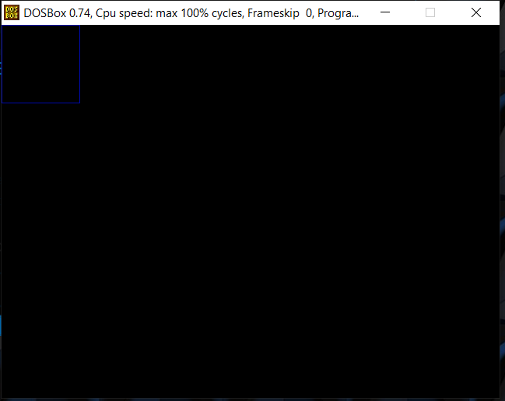

REFLECTION:

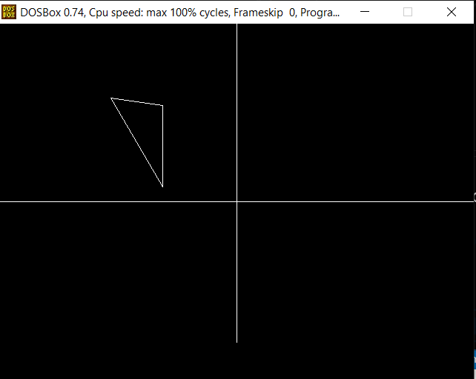

ROTATION:

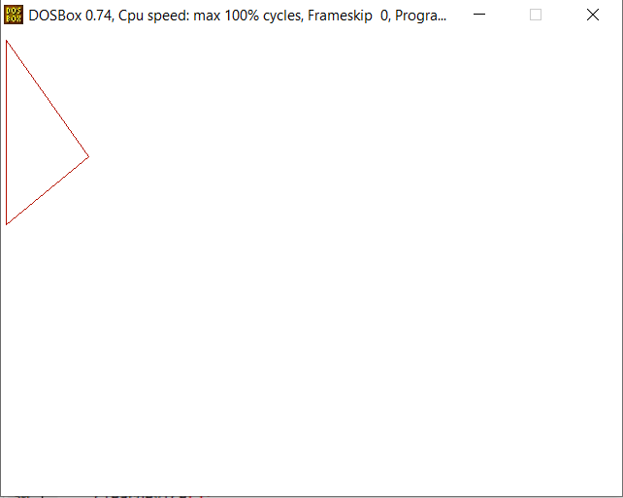

SCALING:

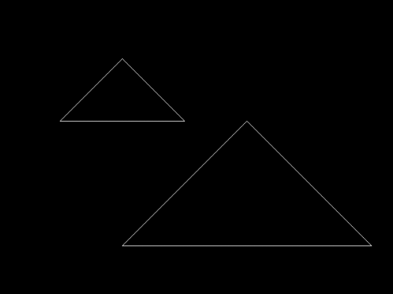

SHEARING ALONG X-AXIS:

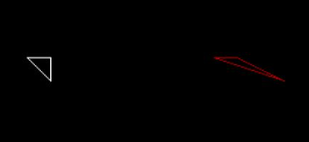

SHEARING ALONG Y-AXIS:

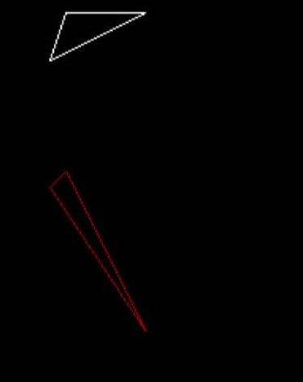

**Lab 7:3D Transformation**

#include <stdio.h>

#include <graphics.h>

#include <math.h>

#include <stdlib.h>

#include <dos.h>

#include <conio.h>

#define ORG -50

# define f 0.3

# define projection_angle 45

void show_screen( );

void apply_x_shearing(int[5][3],constfloat,constfloat);

void multiply_matrices(constfloat[4],constfloat[4][4],float[4]);

void draw_pyramid(constint [5][3]);

void get_projected_point(int&,int&,int&);

void Line(constint,constint,constint,constint);

void show_screen( );

void apply_y_shearing(int[5][3],constfloat,constfloat);

void multiply_matrices(constfloat[4],constfloat[4][4],float[4]);

void trans();

#define ORG -50

double face1[5][2] = {

{ 250, 125 },

{ 350, 125 },

{ 350, 225 },

{ 250, 225 },

{ 250, 125 }

};

double face2[5][2] = {

{ 250+ORG, 125-ORG },

{ 350+ORG, 125-ORG },

{ 350+ORG, 225-ORG },

{ 250+ORG, 225-ORG },

{ 250+ORG, 125-ORG }

};

double angle = 5.0 * M_PI / 180;

double midx1, midy1, midx2, midy2;

void rotate (void)

{

int i;

for (i=0; i<5; i++)

{

double xnew, ynew;

xnew = midx1 + (face1[i][0] - midx1) * cos (angle) -

(face1[i][1] - midy1) * sin (angle);

ynew = midy1 + (face1[i][0] - midx1) * sin (angle) +

(face1[i][1] - midy1) * cos (angle);

face1[i][0] = xnew;

face1[i][1] = ynew;

xnew = midx2 + (face2[i][0] - midx2) * cos (angle) -

(face2[i][1] - midy2) * sin (angle);

ynew = midy2 + (face2[i][0] - midx2) * sin (angle) +

(face2[i][1] - midy2) * cos (angle);

face2[i][0] = xnew;

face2[i][1] = ynew;

}

cleardevice();

for (i=0; i<4; i++)

{

setcolor(7);

line (face1[i][0], face1[i][1], face1[i+1][0], face1[i+1][1]);

setcolor(8);

line (face2[i][0], face2[i][1], face2[i+1][0], face2[i+1][1]);

setcolor(9);

line (face1[i][0], face1[i][1], face2[i][0], face2[i][1]);

}

delay (125);

}

void apply_y_shearing(int edge_points[5][3],constfloat a,constfloat b)

{

for(int count=0;count<5;count++)

{

float matrix_a[4]={edge_points[count][0],edge_points[count][1],

edge_points[count][2],1};

float matrix_b[4][4]={

{ 1,0,0,0 } ,

{ a,1,b,0 } ,

{ 0,0,1,0 } ,

{ 0,0,0,1 }

};

float matrix_c[4]={0};

multiply_matrices(matrix_a,matrix_b,matrix_c);

edge_points[count][0]=(int)(matrix_c[0]+0.5);

edge_points[count][1]=(int)(matrix_c[1]+0.5);

edge_points[count][2]=(int)(matrix_c[2]+0.5);

}

}

//these are left,top,right,bottom parameters for bar3d function

int maxx,maxy,midx,midy;

//function for translation of a 3d object

void trans()

{

int x,y,z,o,x1,x2,y1,y2;

midx=200;

midy=200;

//function to draw 3D rectangular box

bar3d(midx+50,midy-100,midx+100,midy-50,20,1);

delay(1000);

printf("Enter translation factor");

scanf("%d%d",&x,&y);

printf("After translation:");

bar3d(midx+x+50,midy-(y+100),midx+x+100,midy-(y+50),20,1);

}

int x1,x2,y1,y2,mx,my,depth;

void draw();

void rotate();

void rotate()

{

float t;

int a1,b1,a2,b2,dep;

printf("Enter the angle to rotate=");

scanf("%f",&t);

t=t*(3.14/180);

a1=mx+(x1-mx)*cos(t)-(y1-my)*sin(t);

a2=mx+(x2-mx)*cos(t)-(y2-my)*sin(t);

b1=my+(x1-mx)*sin(t)-(y1-my)*cos(t);

b2=my+(x2-mx)*sin(t)-(y2-my)*cos(t);

if(a2>a1)

dep=(a2-a1)/4;

else

dep=(a1-a2)/4;

bar3d(a1,b1,a2,b2,dep,1);

setcolor(5);

//draw();

}

void draw()

{

bar3d(x1,y1,x2,y2,depth,1);

}

void scale();

//these are left,top,right,bottom parameters for bar3d function

int maxx,maxy,midx,midy;

//function for scaling of a 3d object

void scale()

{

int x,y,z,o,x1,x2,y1,y2;

midx=200;

midy=200;

bar3d(midx+50,midy-100,midx+100,midy-50,20,0);

printf("before scaling\n");

printf("Enter scaling factors\n");

scanf("%d %d %d", &x,&y,&z);

printf("After scaling\n");

bar3d(midx+(x*50),midy-(y*100),midx+(x*100),midy-(y*50),20*z,1);

}

void Line(constint,constint,constint,constint);

double face1[5][2] = {

{ 250, 125 },

{ 350, 125 },

{ 350, 225 },

{ 250, 225 },

{ 250, 125 }

};

double face2[5][2] = {

{ 250+ORG, 125-ORG },

{ 350+ORG, 125-ORG },

{ 350+ORG, 225-ORG },

{ 250+ORG, 225-ORG },

{ 250+ORG, 125-ORG }

};

double angle = 5.0 * M_PI / 180;

double midx1, midy1, midx2, midy2;

void rotate (void)

{

int i;

for (i=0; i<5; i++)

{

double xnew, ynew;

xnew = midx1 + (face1[i][0] - midx1) * cos (angle) -

(face1[i][1] - midy1) * sin (angle);

ynew = midy1 + (face1[i][0] - midx1) * sin (angle) +

(face1[i][1] - midy1) * cos (angle);

face1[i][0] = xnew;

face1[i][1] = ynew;

xnew = midx2 + (face2[i][0] - midx2) * cos (angle) -

(face2[i][1] - midy2) * sin (angle);

ynew = midy2 + (face2[i][0] - midx2) * sin (angle) +

(face2[i][1] - midy2) * cos (angle);

face2[i][0] = xnew;

face2[i][1] = ynew;

}

cleardevice();

for (i=0; i<4; i++)

{

setcolor(7);

line (face1[i][0], face1[i][1], face1[i+1][0], face1[i+1][1]);

setcolor(8);

line (face2[i][0], face2[i][1], face2[i+1][0], face2[i+1][1]);

setcolor(9);

line (face1[i][0], face1[i][1], face2[i][0], face2[i][1]);

}

delay (125);

}

void show_screen( );

void apply_x_shearing(int[5][3],constfloat,constfloat);

void multiply_matrices(constfloat[4],constfloat[4][4],float[4]);

void draw_pyramid(constint [5][3]);

void get_projected_point(int&,int&,int&);

void Line(constint,constint,constint,constint);

int main( )

{

int driver=VGA;

int mode=VGAHI;

initgraph(&driver,&mode,"C:\\TURBOC3\\BGI");

show_screen( );

int pyramid[5][3]={

{280,220,40}, // base front left

{360,220,40}, // base front right

{360,220,-40}, // base back right

{280,220,-40}, // base back left

{320,100,0} // top

};

setcolor(15);

draw_pyramid(pyramid);

setcolor(15);

settextstyle(0,0,1);

outtextxy(50,415,"*** Press any key to see the 3D Shearing along x-axis.");

apply_x_shearing(pyramid,0.4,0.3);

getch( );

setcolor(10);

draw_pyramid(pyramid);

getch( );

return 0;

}

void apply_x_shearing(int edge_points[5][3],constfloat a,constfloat b)

{

for(int count=0;count<5;count++)

{

float matrix_a[4]={edge_points[count][0],edge_points[count][1],

edge_points[count][2],1};

float matrix_b[4][4]={

{ 1,a,b,0 } ,

{ 0,1,0,0 } ,

{ 0,0,1,0 } ,

{ 0,0,0,1 }

};

float matrix_c[4]={0};

multiply_matrices(matrix_a,matrix_b,matrix_c);

edge_points[count][0]=(int)(matrix_c[0]+0.5);

edge_points[count][1]=(int)(matrix_c[1]+0.5);

edge_points[count][2]=(int)(matrix_c[2]+0.5);

}

}

void multiply_matrices(constfloat matrix_1[4],

constfloat matrix_2[4][4],float matrix_3[4])

{

for(int count_1=0;count_1<4;count_1++)

{

for(int count_2=0;count_2<4;count_2++)

matrix_3[count_1]+=

(matrix_1[count_2]*matrix_2[count_2][count_1]);

}

}

void draw_pyramid(constint points[5][3])

{

int edge_points[5][3];

for(int i=0;i<5;i++)

{

edge_points[i][0]=points[i][0];

edge_points[i][1]=points[i][1];

edge_points[i][2]=points[i][2];

get_projected_point(edge_points[i][0],

edge_points[i][1],edge_points[i][2]);

}

Line(edge_points[0][0],edge_points[0][1],

edge_points[1][0],edge_points[1][1]);

Line(edge_points[1][0],edge_points[1][1],

edge_points[2][0],edge_points[2][1]);

Line(edge_points[2][0],edge_points[2][1],

edge_points[3][0],edge_points[3][1]);

Line(edge_points[3][0],edge_points[3][1],

edge_points[0][0],edge_points[0][1]);

Line(edge_points[0][0],edge_points[0][1],

edge_points[4][0],edge_points[4][1]);

Line(edge_points[1][0],edge_points[1][1],

edge_points[4][0],edge_points[4][1]);

Line(edge_points[2][0],edge_points[2][1],

edge_points[4][0],edge_points[4][1]);

Line(edge_points[3][0],edge_points[3][1],

edge_points[4][0],edge_points[4][1]);

}

void get_projected_point(int& x,int& y,int& z)

{

float fcos0=(f*cos(projection_angle*(M_PI/180)));

float fsin0=(f*sin(projection_angle*(M_PI/180)));

float Par_v[4][4]={

{1,0,0,0},

{0,1,0,0},

{fcos0,fsin0,0,0},

{0,0,0,1}

};

float xy[4]={x,y,z,1};

float new_xy[4]={0};

multiply_matrices(xy,Par_v,new_xy);

x=(int)(new_xy[0]+0.5);

y=(int)(new_xy[1]+0.5);

z=(int)(new_xy[2]+0.5);

}

void Line(constint x_1,constint y_1,constint x_2,constint y_2)

{

int color=getcolor( );

int x1=x_1;

int y1=y_1;

int x2=x_2;

int y2=y_2;

if(x_1>x_2)

{

x1=x_2;

y1=y_2;

x2=x_1;

y2=y_1;

}

int dx=abs(x2-x1);

int dy=abs(y2-y1);

int inc_dec=((y2>=y1)?1:-1);

if(dx>dy)

{

int two_dy=(2*dy);

int two_dy_dx=(2*(dy-dx));

int p=((2*dy)-dx);

int x=x1;

int y=y1;

putpixel(x,y,color);

while(x<x2)

{

x++;

if(p<0)

p+=two_dy;

else

{

y+=inc_dec;

p+=two_dy_dx;

}

putpixel(x,y,color);

}

}

else

{

int two_dx=(2*dx);

int two_dx_dy=(2*(dx-dy));

int p=((2*dx)-dy);

int x=x1;

int y=y1;

putpixel(x,y,color);

while(y!=y2)

{

y+=inc_dec;

if(p<0)

p+=two_dx;

else

{

x++;

p+=two_dx_dy;

}

putpixel(x,y,color);

}

}

}

void show_screen( )

{

setfillstyle(1,1);

bar(210,26,420,38);

settextstyle(0,0,1);

setcolor(15);

outtextxy(5,5,"******************************************************************************");

outtextxy(5,17,"*-**************************************************************************-*");

outtextxy(5,29,"*----------------------- ------------------------*");

outtextxy(5,41,"*-**************************************************************************-*");

outtextxy(5,53,"*-**************************************************************************-*");

setcolor(11);

outtextxy(218,29,"3D Shearing along x-axis");

setcolor(15);

for(int count=0;count<=30;count++)

outtextxy(5,(65+(count*12)),"*-* *-*");

outtextxy(5,438,"*-**************************************************************************-*");

outtextxy(5,450,"*------------------------- -------------------------*");

outtextxy(5,462,"******************************************************************************");

setcolor(12);

outtextxy(229,450,"Press any Key to exit.");

}

int main () {

char choice;

printf("Enter 1 for translation,2 for reflection,3 for rotation,4 for scaling,5 for shearing along x axis,6 for shearing along y axis.\n");

scanf("%c", &choice)

switch(choice) {

case '1' :int ch;

int gd=DETECT,gm;

detectgraph(&gd,&gm);

initgraph(&gd,&gm,"C:\\TURBOC3\\BGI");

trans();

break;

case '2' :

int gd = DETECT, gm;

midx1 = (face1[0][0] + face1[1][0]) / 2.0;

midy1 = (face1[1][1] + face1[2][1]) / 2.0;

midx2 = (face2[0][0] + face2[1][0]) / 2.0;

midy2 = (face2[1][1] + face2[2][1]) / 2.0;

initgraph (&gd, &gm, "C:\\TURBOC3\\BGI");

while (!kbhit())

rotate();

closegraph();

break;

case '3' :

int gd=DETECT,gm,c;

initgraph(&gd,&gm,"C:\\TURBOC3\\BGI");

printf("\n3D Transformation Rotating\n\n");

printf("\nEnter 1st top value(x1,y1):");

scanf("%d%d",&x1,&y1);

printf("Enter right bottom value(x2,y2):");

scanf("%d%d",&x2,&y2);

depth=(x2-x1)/4;

mx=(x1+x2)/2;

my=(y1+y2)/2;

draw();

getch();

cleardevice();

rotate();

getch();

break;

case '4' : int ch;

int gd=DETECT,gm;

detectgraph(&gd,&gm);

initgraph(&gd,&gm,"C:\\TURBOC3\\BGI");

scale();

break;

case '5':int driver=VGA;

int mode=VGAHI;

initgraph(&driver,&mode,"C:\\TURBOC3\\BGI");

show_screen( );

int pyramid[5][3]={

{280,220,40}, // base front left

{360,220,40}, // base front right

{360,220,-40}, // base back right

{280,220,-40}, // base back left

{320,100,0} // top

};

setcolor(15);

draw_pyramid(pyramid);

setcolor(15);

settextstyle(0,0,1);

outtextxy(50,415,"*** Press any key to see the 3D Shearing along x-axis.");

apply_x_shearing(pyramid,0.4,0.3);

getch( );

setcolor(10);

draw_pyramid(pyramid);

getch( );

break;

case '6':int driver=VGA;

int mode=VGAHI;

initgraph(&driver,&mode,"C:\\TURBOC3\\BGI");

show_screen( );

int pyramid[5][3]={

{270,300,50}, // base front left

{370,300,50}, // base front right

{370,300,-50}, // base back right

{270,300,-50}, // base back left

{320,150,0} // top

};

setcolor(15);

draw_pyramid(pyramid);

setcolor(15);

settextstyle(0,0,1);

outtextxy(50,415,"*** Press any key to see the 3D Shearing along y-axis.");

apply_y_shearing(pyramid,0.5,0.1);

getch( );

setcolor(10);

draw_pyramid(pyramid);

getch( );

default :

printf("Wrong Choice.Try Again.\n" );

}

return 0;

}

**TRANSLATION:**

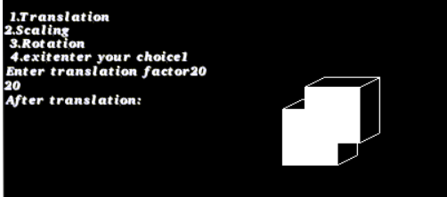

**SCALING:**

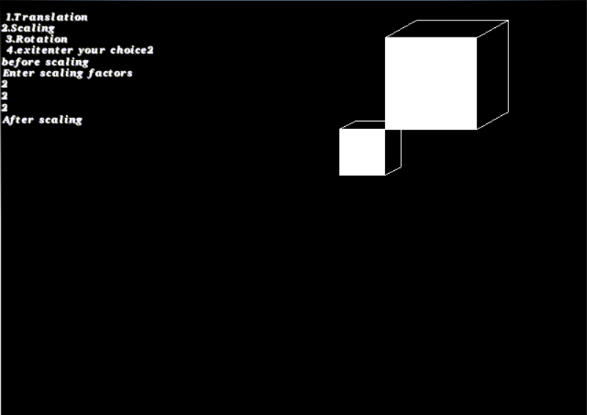

**ROTATION:**

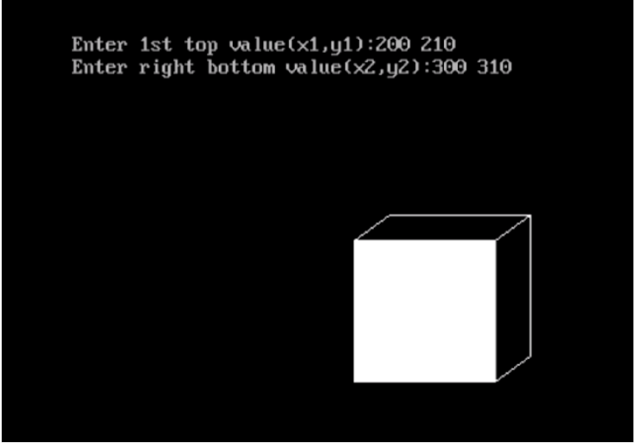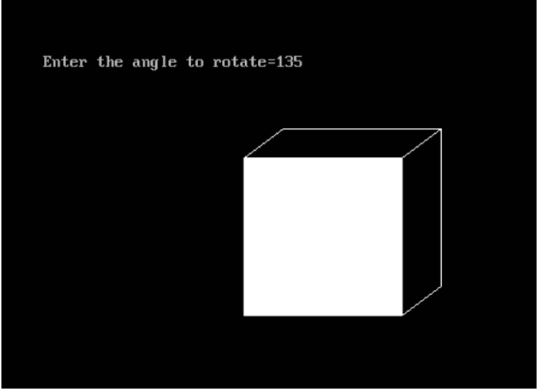

**REFLECTION:**

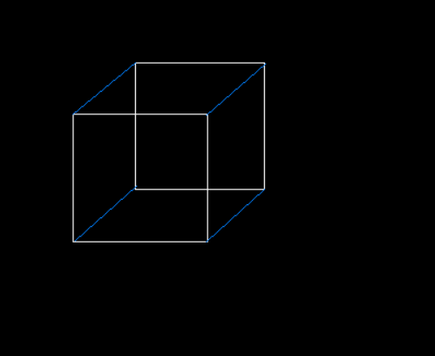

**SHEARING:**

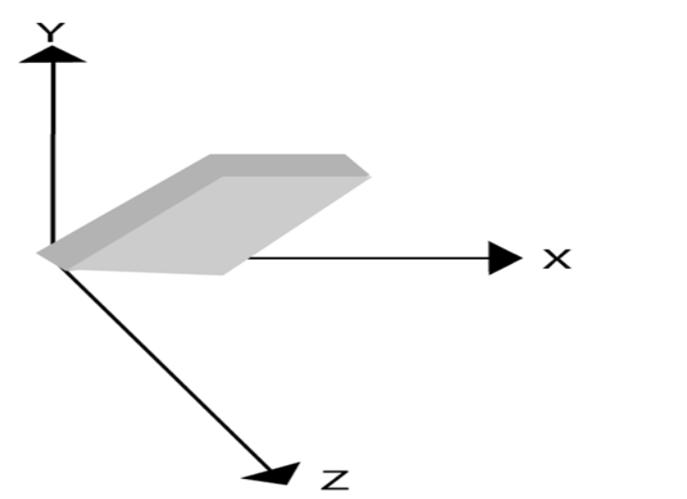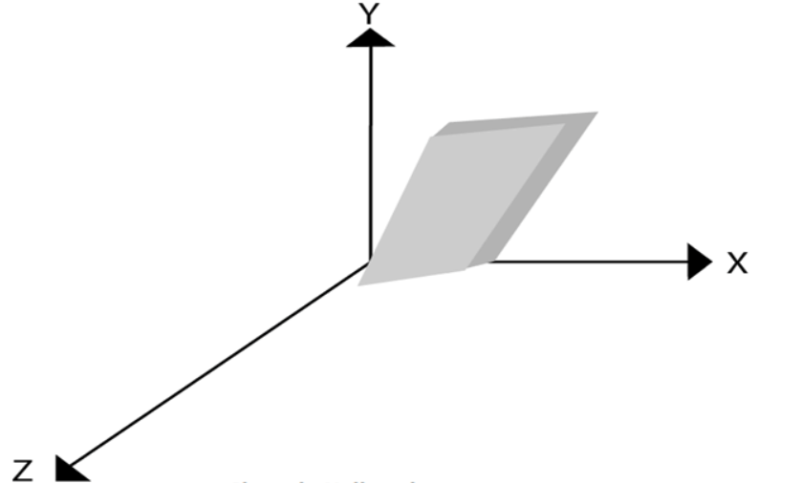

**Lab 8:Audio Editing**

**Drive Link:** **https://drive.google.com/drive/folders/10abxunpu08QHtXNJNo_4haiAAFIzsMr6?usp=sharing**

Use a audio processing software and perform the audio editing tasks–

Import audio

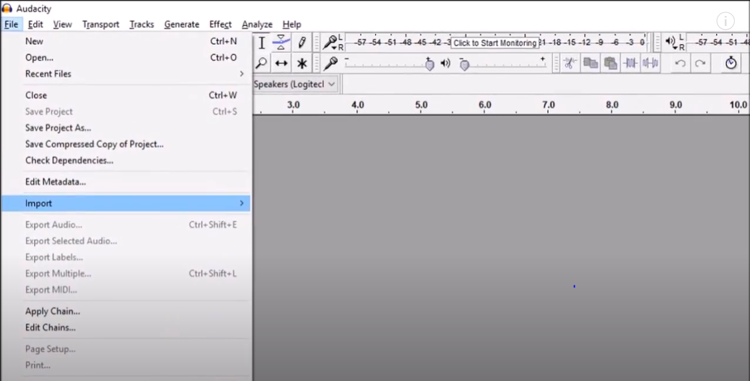

Select and edit the sound

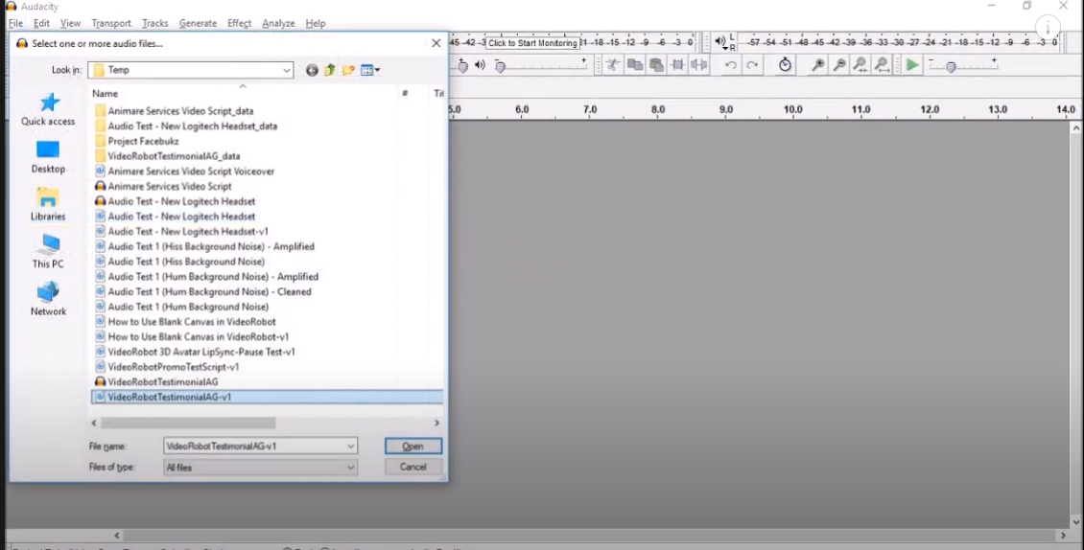

Create fade-in fade-out effects

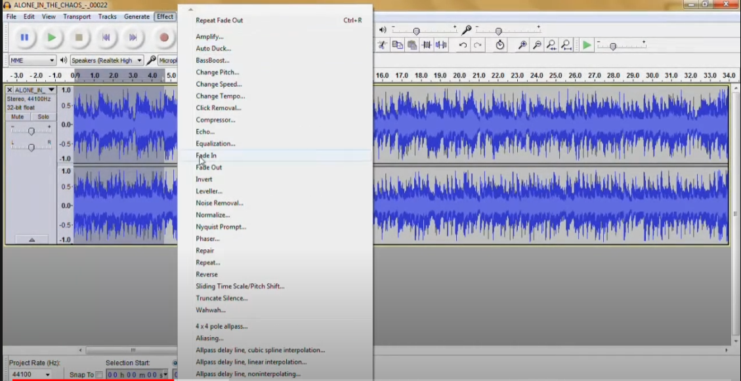

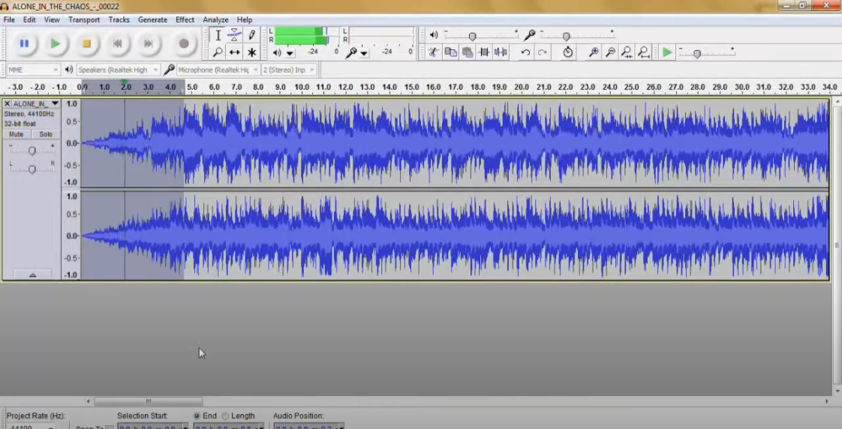

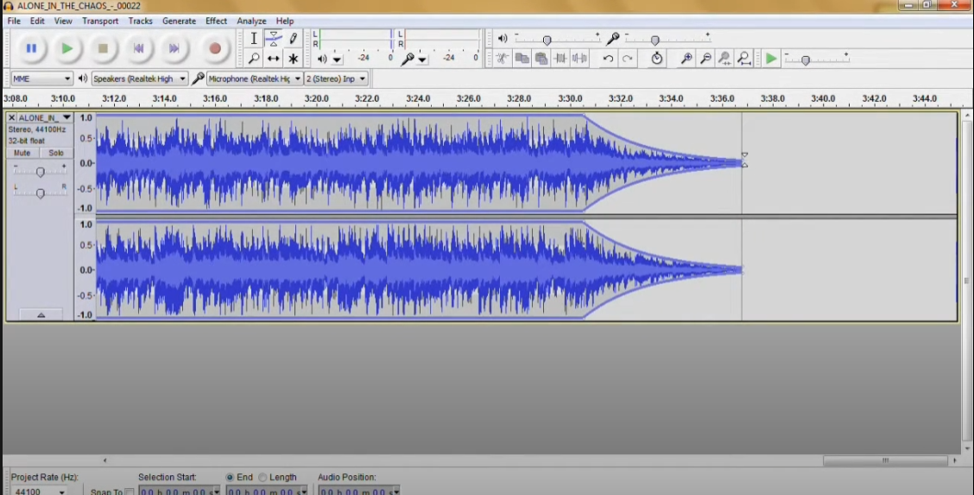

, Label audio segments,

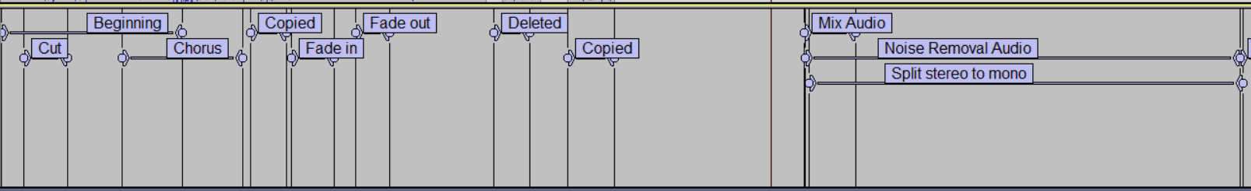

Use noise remove filter

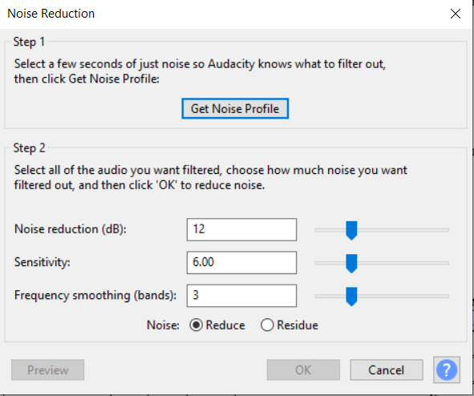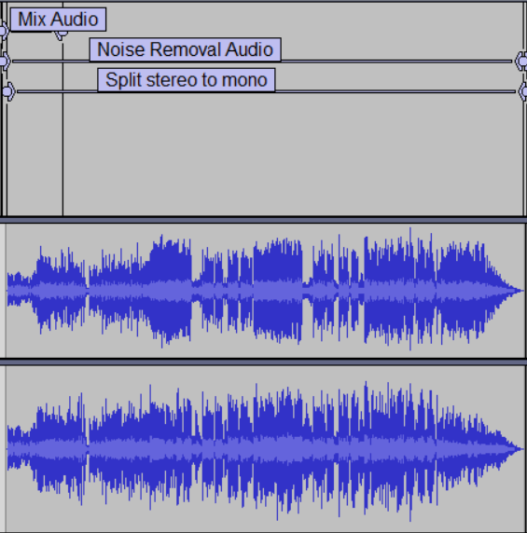

, Mix audio

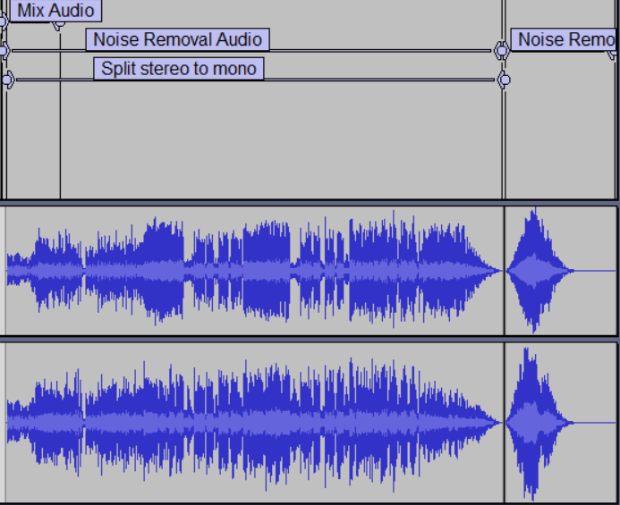

, **Change stereo to mono tracks**

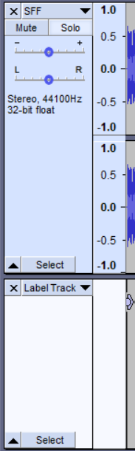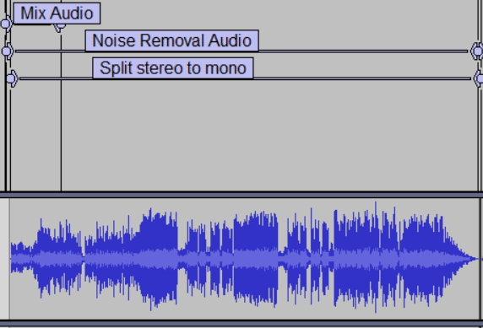

Export audio to different format and save.

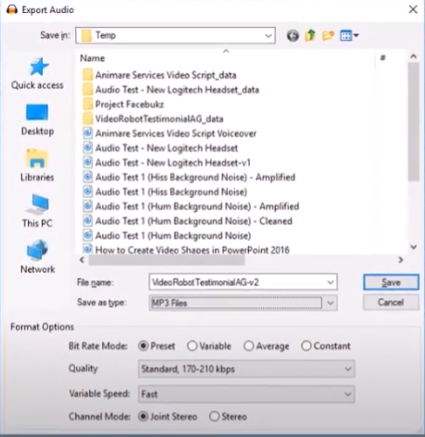

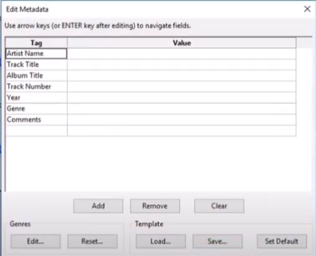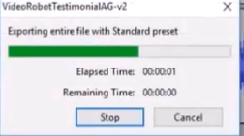

​

**Lab 9:Video Editing**

Use a video processing Software to perform – Trim video clips, crop video, rotate video, join video, add subtitles, and edit video dimension, bit rate, 3 hoursframe rate, sample rate, channel on a video.

Premiere Pro CC

Gdrive Link: <https://drive.google.com/file/d/1M_jqFVGbfmOTnn0Ga1wL3Nne7JsGrxqI/view?usp=sharing>

Video Link: https://www.youtube.com/watch?v=WBwvKGc9ySc

Trim video clips

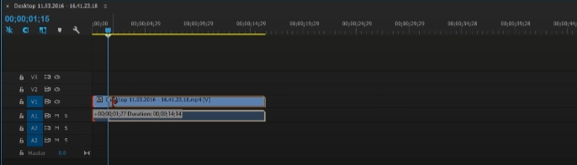

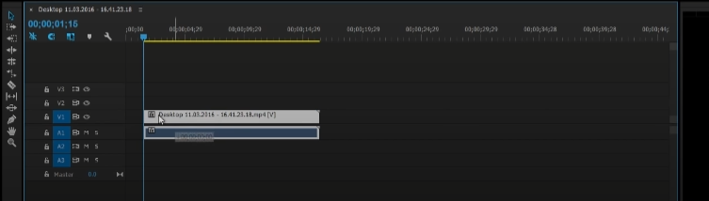

crop video

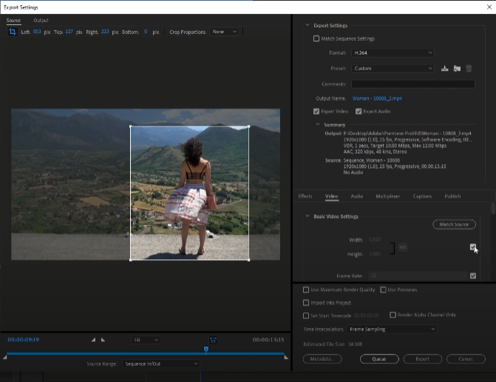

rotate video

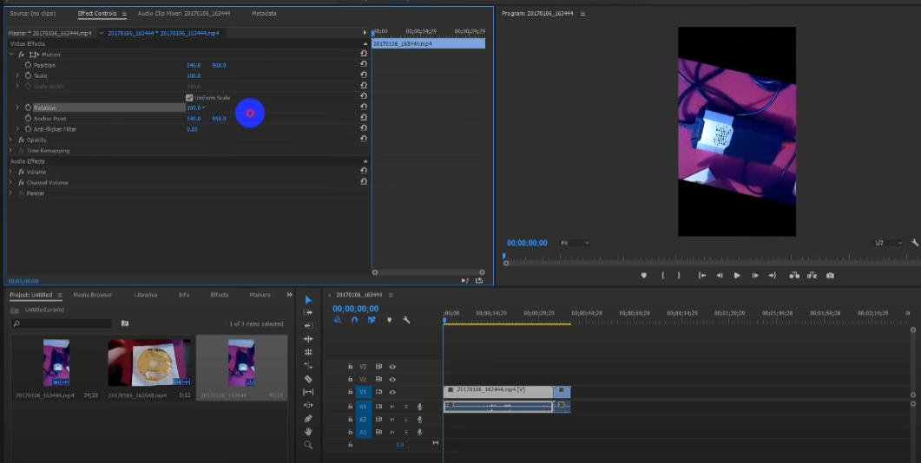

join video

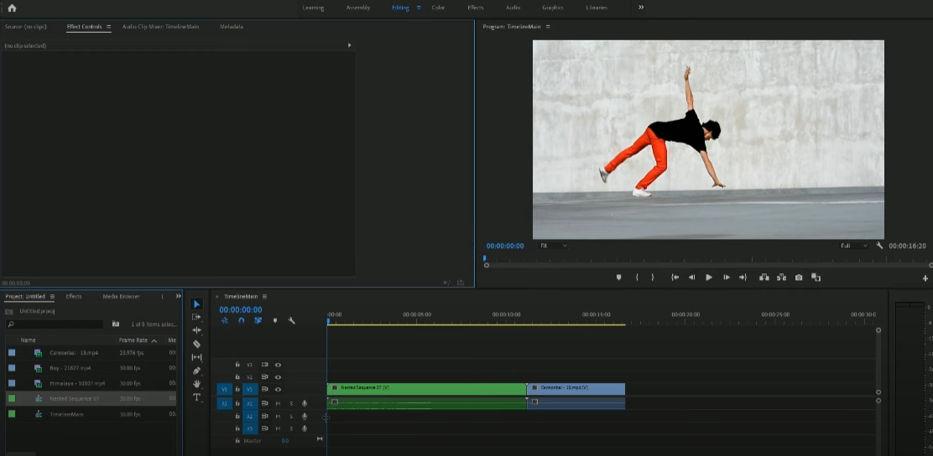

add subtitles

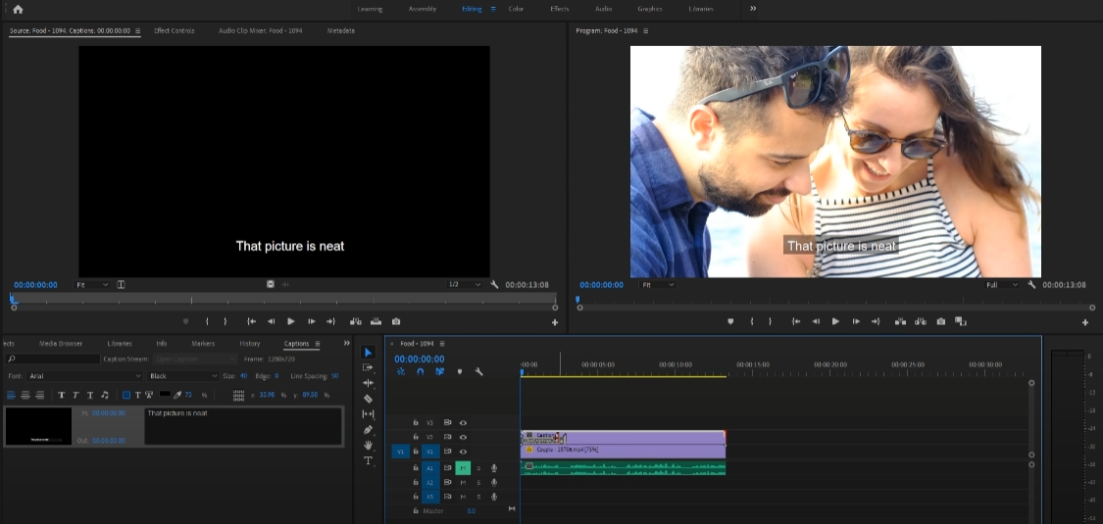

edit video dimension

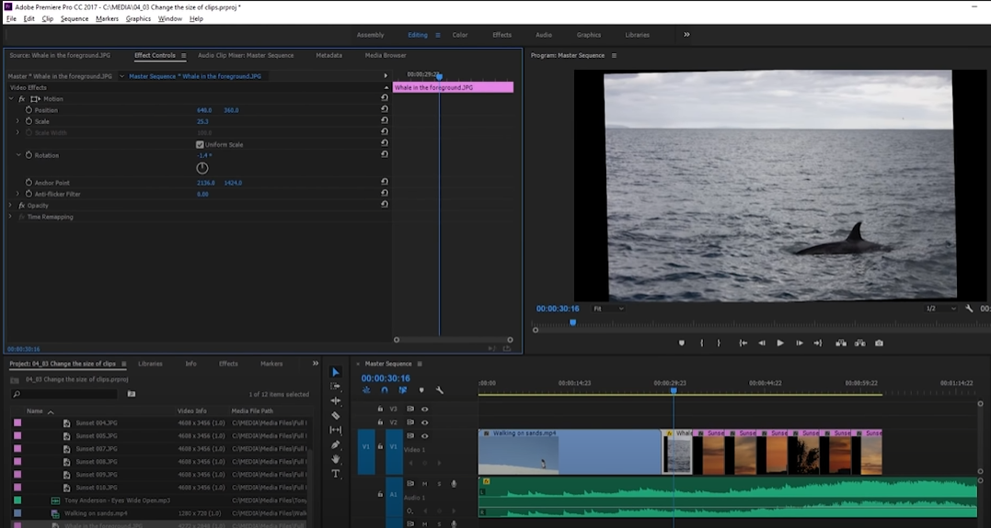

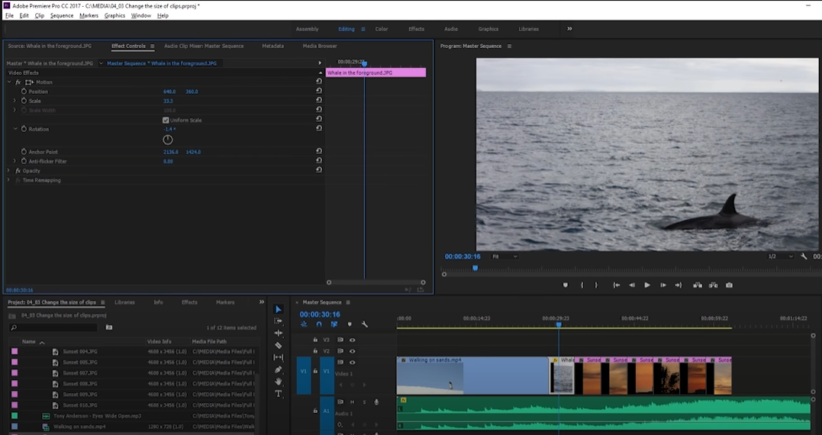

bit rate

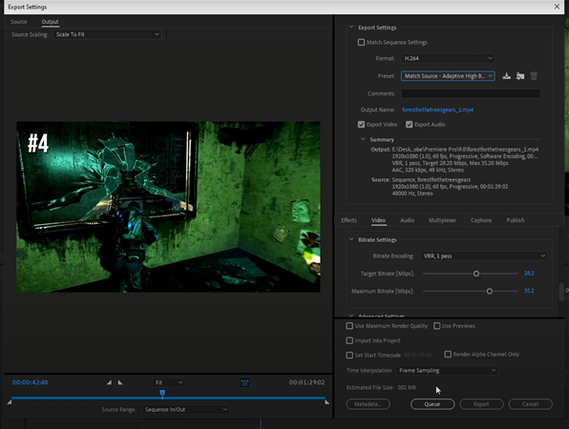

sample rate

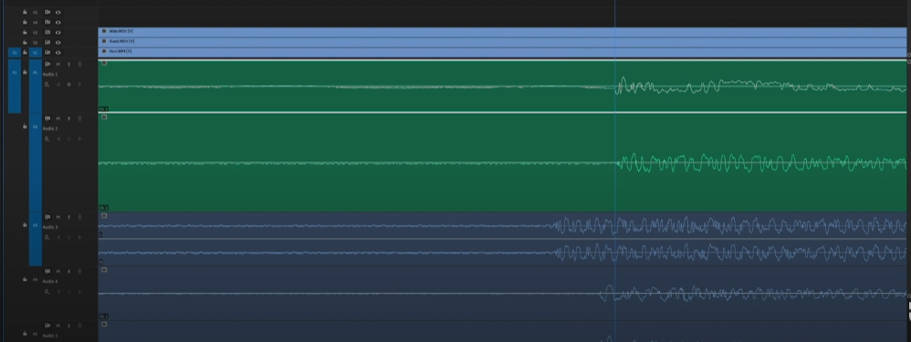

channel on a video

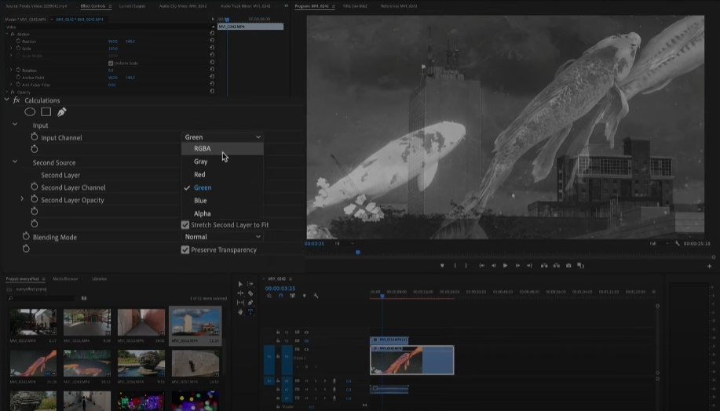

**Lab 10:Animation Making**

**Link:**

**https://drive.google.com/file/d/1y8J90ff-6LjCdpmCw64xDgc-UuRfY94j/view?usp=sharing**

